Grade 7 Accelerated · Unit 3 · Lesson 5  Applying Exponent Laws  Question Bank 3.05 | Name______________________  Date______________________  Period____________________

Show your work. Circle your final answer.
For questions 1 through 4, rewrite each expression as an equivalent expression with a positive exponent.
1. 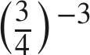

2. 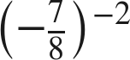

3. 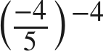

4. 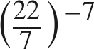

Matching.
5. Match each expression on the left with the equivalent expression on the right by writing the letter.
a. 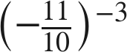 A. 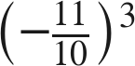 B. 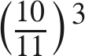 C. 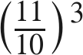 D. 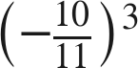

b. 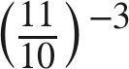

c. 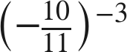

d. 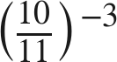

For questions 6 through 9, generate an equivalent expression with one base and one positive exponent. Show the laws you use.
6. 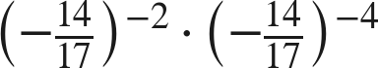

7. 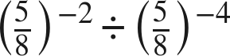

8. 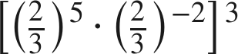

9. 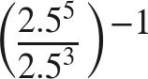

Equivalent or not.
10. Consider the expression 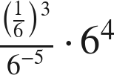. For each expression below, decide whether it is equivalent, and justify with a law of exponents.
a. 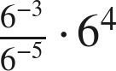

b. 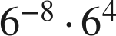

c. 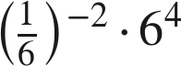

d. 

11. Which is the value of 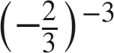 ?
○ A. 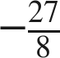
○ B. 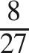
○ C. 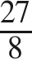
○ D. 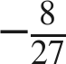

12. Find the value of that makes each statement true.
a. 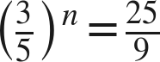

b. 